Movie Budget Analysis (OOP in Python)

Python.file:

Screenshot:

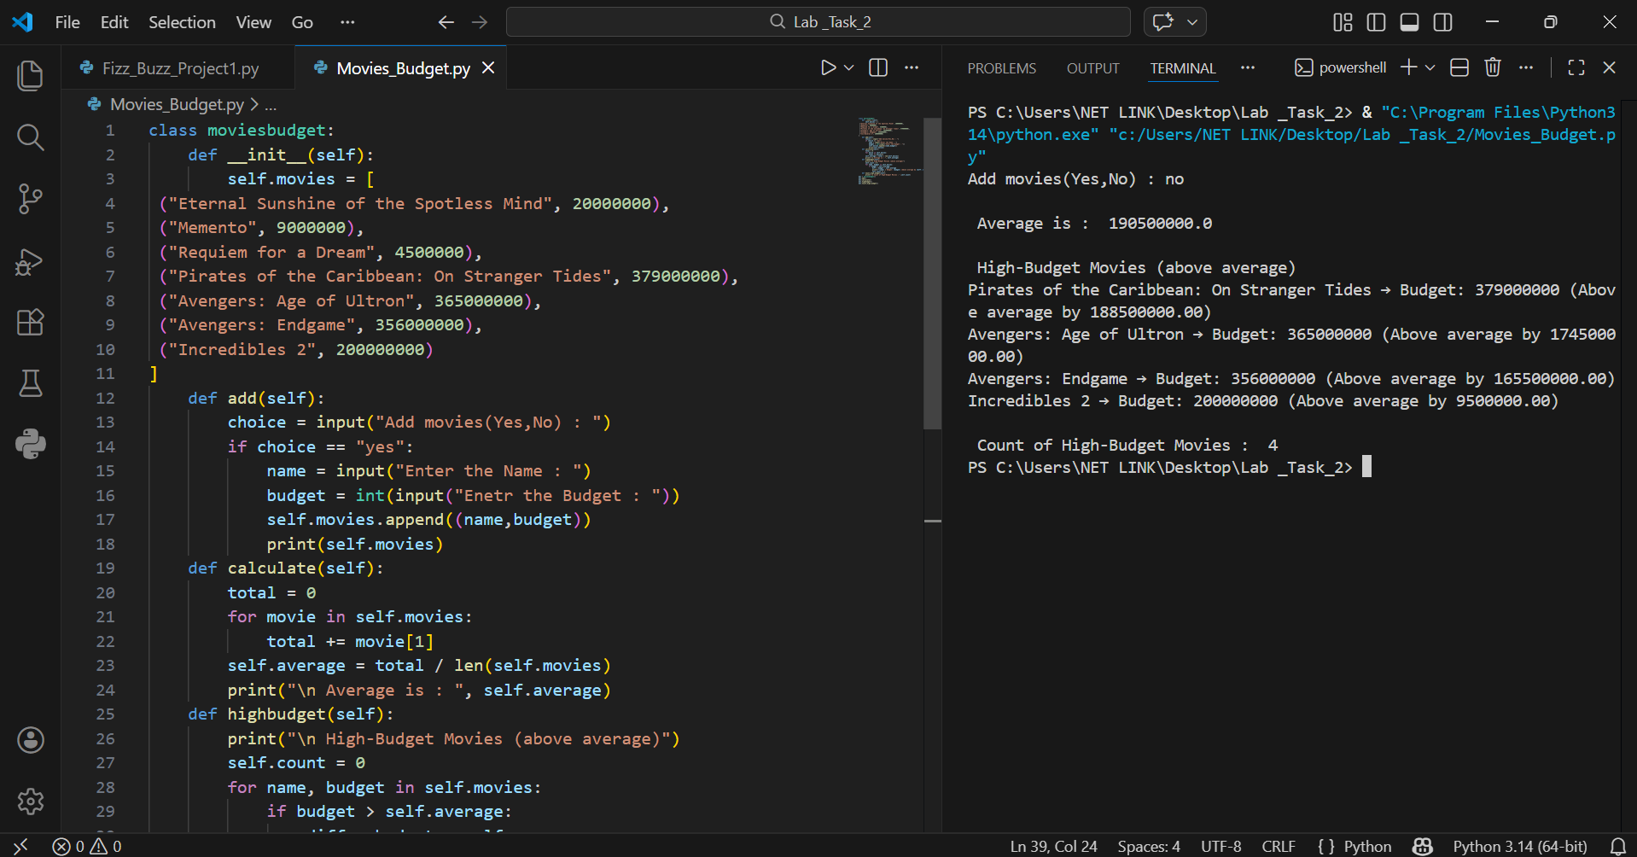

Details
This Python program is a simple Movies Budget system using Object-Oriented Programming (OOP).
It allows the user to:
- Add new movies
- Calculate the average budget
- Display high-budget movies (movies above average)
- Show count of high-budget movies
The program runs in the terminal.

Main Components
- Class: moviesbudget
- Attribute: self.movies (stores list of movies with budget)
- Methods:
  - Add() → To add movies
  - Calculate() → To calculate average budget
  - highbudget() → To display high-budget movies
  - Count_high_budget() → To count high-budget movies
- Loop: Iterates through movie list to apply conditions

How the Program Works

1. Start
- The program creates an object of the moviesbudget class.
- Initial list of movies is stored in self.movies.

2. Adding Movies
- User is asked if they want to add more movies.
- If yes → User can input movie name and budget, which is appended to self.movies.

3. Calculate Average
- Total budget of all movies is calculated.
- Average is found by dividing total budget / number of movies.

4. High-Budget Movies
- Loop through all movies.
- If movie budget > average → print movie name, budget, and difference from average.
- Count is increased for each high-budget movie.

5. Count High-Budget Movies
- Total number of high-budget movies is displayed.

